CS 255 System Design Document Template

This template lays out all the different sections that you need to complete for Project Two. Each section has guidance to prompt your thinking. You will need to continually reference the interview transcript as you work to make sure that you are addressing your client’s needs. There is no required length for the final document. Instead the goal is to complete each section based on what your client’s needs are. Remove this note when you are finished, and replace all bracketed text with the relevant information.

UML Diagrams

UML Use Case Diagram

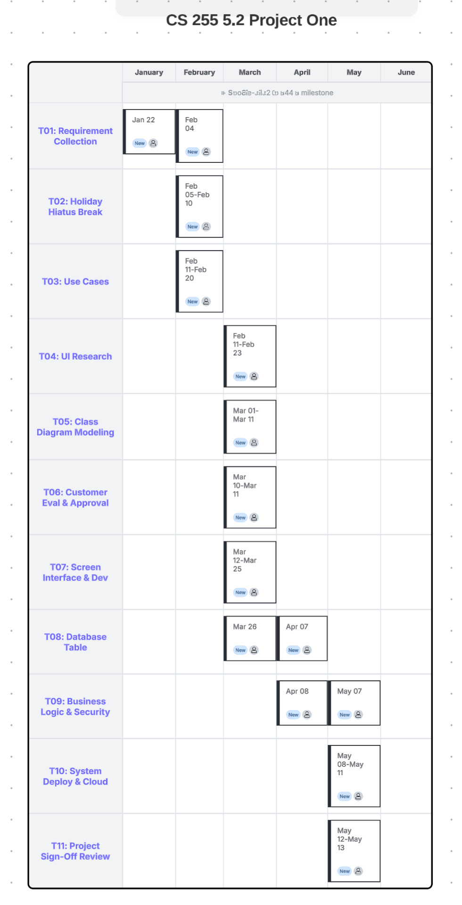

UML Activity Diagrams
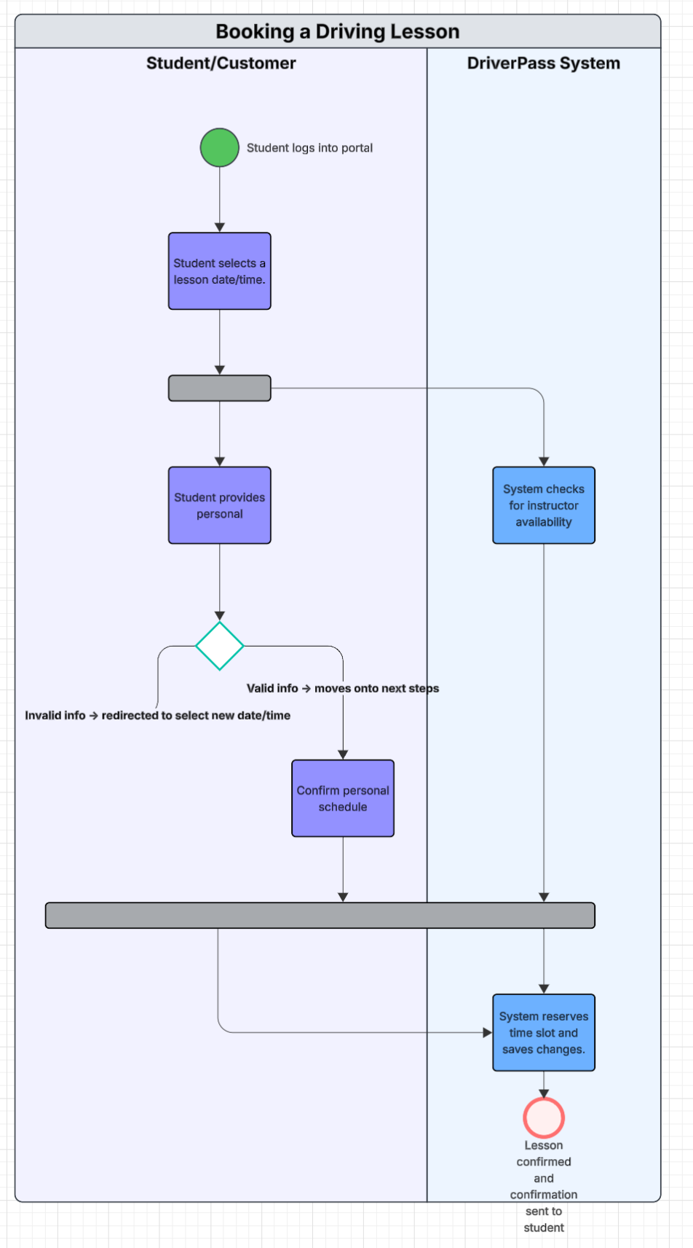

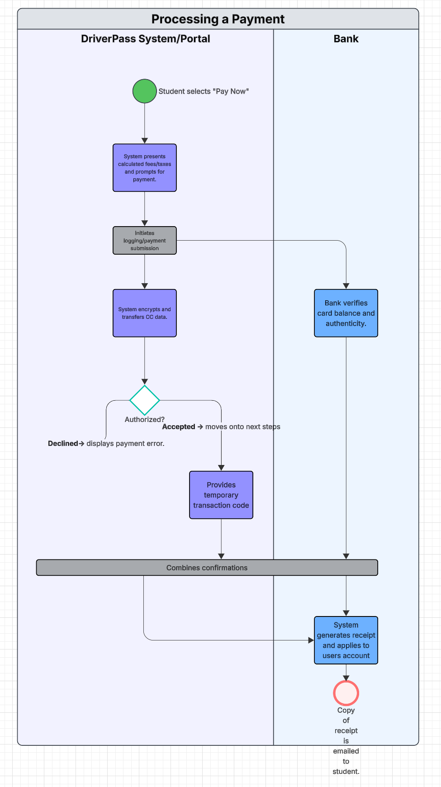

UML Sequence Diagram
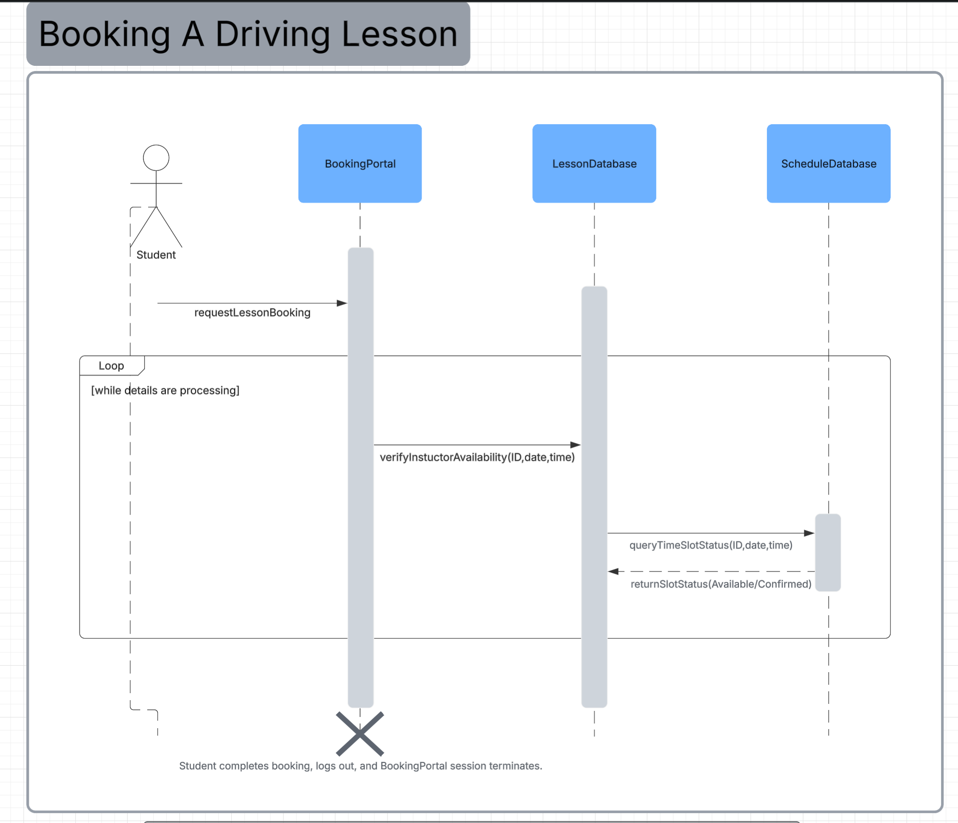

UML Class Diagram
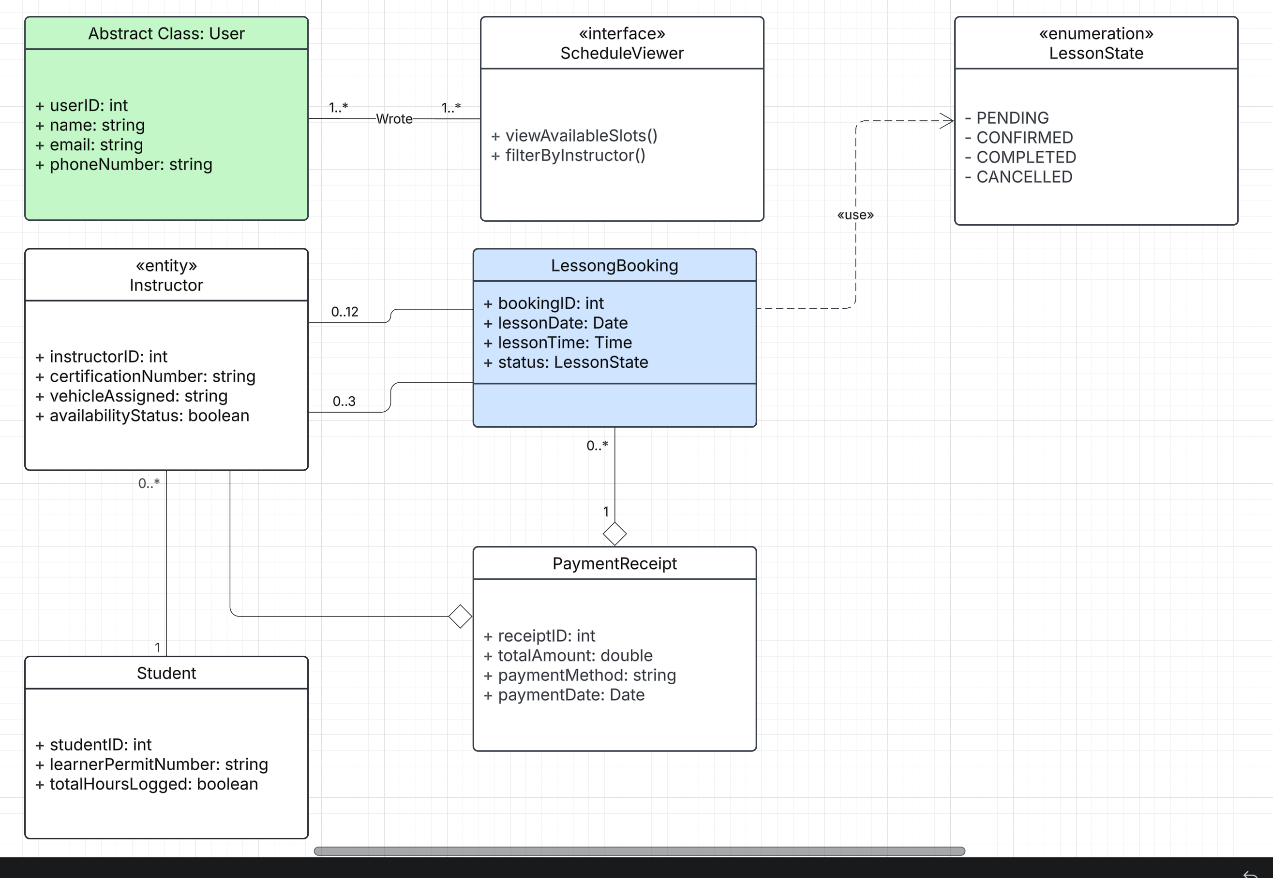

Technical Requirements

- Hardware
    - Infrastructure and Server Hosting
      - Cloud Infrastructure: a minimum of 4 vCPUs with 16 GB RAM and expandable SSD to handle high user traffic during peak booking hours.
      - Server: dedicated instances with a minimum of 2vCPUs with 8 GB RAM that use high-speed provisioning options to support quick transaction sorting and updating operations.
    - User and Client Hardware
        - Staff terminal: standard workstations/laptops running up to date processors with at least 8 GB RAM and stable internet.
        - User device: cross platform compatible with any modern mobile device (tablet, PC, smartphone) or OS.
- Software
    - Architecture and Logic
        - Backend environment: Node.js or Java Spring Boot will be used to handle core logic defined in the LessonController sequence diagram.
        - Frontend environment: web apps like React.js or Angular will be used to render clean displays for the student portal.
    - Storage and OS
        - Database management: MySQL will house critical structures defined in the UML class diagram.
        - OS: prod environments will run securely inside lightweight distributions like Ubuntu or Linux.
- Tools
    - Payment and Comms
        - Payment API: integration with a Lvl PCI compliant payment merchant like Stripe to offload financial fraud confirmation, payment processing, etc.
        - Notifications: messaging tools like Twilio will handle automated receipts and confirmations directly to the email of the purchaser.
    - Internal Dev
        - CASE Modeling: Lucidchart will be used to build, export, etc diagrams.
        - Source control: GitHub version control will be used to handle code deployment pipelines, branch isolation, and dev schedules.
- Infrastructure
    - Network Security
        - TLS encryption: Mandatory SSL/TLS generating HTTPS comms layers to encrypt personal student learner permit data and creds.
        - Cloud provider: AWS or Azure can be used to contain systems to dynamically scale up or down throughout the year.

